***An Information & Welcome pack for parents and carers***

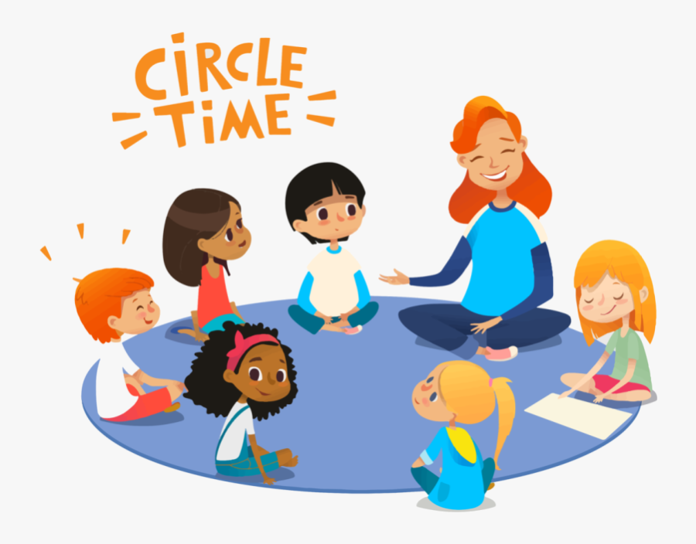

***Tullacmongan Childcare Service***

***Welcome Pack***

***Welcome to Tullacmongan Childcare Service***

**Mission statement of Tullacmongan Childcare Services**

Our mission is to value the ability, individuality and cultural background of all children by providing each child with the opportunities they need to reach their full potential as active learners within an inclusive ethos/culture.

At Tullacmongan Childcare Services, we achieve care and inclusion in education by continually reviewing an anti-bias approach that is implemented by the early childhood service, and by working in partnership with families, children and the early childhood team, both individually through reflective practice, and in consultation with children and their families, so as to ensure that the education and care provided is fully inclusive of all children, families and agencies that attend and use our service.

**Our Aims**

Our Aims is to create a happy and safe home from home environment in which our children can grow. We aim to provide high quality childcare and education. To create an environment that is secure, safe and homely. We aim to work in partnership with the parents in their child's development. To offer a service that promotes equality and diversity

**The Early Childhood Care and Education**

The Early Childhood Care and Education (ECCE) Scheme provides early childhood care and education for children of pre-school age.

From September 2020, children can participate in the ECCE scheme from 2 years 8 months of age and continue until they transfer to primary school (provides that they are not older than 5 years and 6 months at the end of the pre-school year).

**Meet the team**

Jenny McCormack-Manager Level 6

Phyllis Duggan- Early Years Practitioner Level 6

Andrea Odjegba- Early Years Practitioner Level 6

Aisling Bogue- Early Years Practitioner Level 6

Gemma Hughes- Early Years Practitioner Level 5

Dympna Loughman- CE Assistant Level 5

Gael Dunne- Early Years Practitioner Level 8

Liga - Caretaker

Tatajana - Caretaker

Sorsha McCaffrey- Administrator

**Session Times**

Morning Session 9am- 12pm

Pre-School is responsible for children during sessions only. We cannot accept responsibility for children outside of the designated hours of care.

**Your child’s first day**

As our session starts from 9 am you will need to stay with and be responsible for your child up until this time. If your child is finding their new experience of starting preschool stressful, please inform a member of staff who will be happy to help in any way which you see fit. This is not uncommon and is a new experience for both the child and parents/carers. You can contact us by phone as often as you need to during the session if you are at all concerned.

**Key Person**

At Tullacmongan Childcare Service we have a key person system. Each child is assigned a key person when they join our setting. This member of staff will act as your key contact and will work with you and your child to plan and deliver your child’s learning journey. We believe that children settle best when they have a key person to relate to, who knows them and their parents/carers well. We believe that your child will feel settled at the preschool when they have formed a good relationship with their key person. They are beneficial to act as a comfort and security for your child.

**What to bring to Pre-school**

* Child’s Immunisation book to be copied
* Bag
* Coat
* Spare set of uniform/ clothes
* Hat/sun cream (summer term)
* Wellington boots (rainy days)

All items that are brought in MUST be CLEARLY NAMED. We cannot be responsible for items that are lost or damaged

**Our Uniform**

Our pre-school uniform consists of a red polo t-shirt and navy jumper and bottoms.

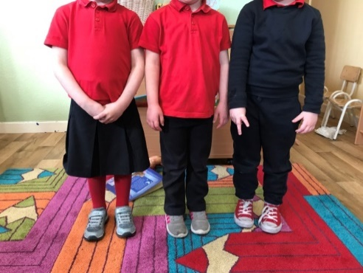

**Recommended Lunch**

A healthy packed lunch (if applicable), such as a sandwich with a healthy filling or fruit. We have a healthy eating policy so we ask not to pack fizzy drinks, yoghurts, biscuits, crisps or sweets. Please cut all small foods in halves as this can be a serious choking hazard. Foods like grapes and blueberries. Lunch must be brought in a clear lunch bag with child’s name clearly labelled. No schoolbags or lunch boxes are to be brought to preschool. Each child should have their own clearly labelled juice bottle.

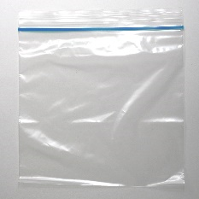****

**Policies**

****Our policies folder can be viewed if requested. You are invited to read through these as they underpin how we run our setting. We particularly draw your attention to our covid19 policy, safeguarding, equal opportunities and behaviour management policies. If you wish for a copy of any policy, please ask.

**If your child is unwell**

Your child should only attend preschool if they are well enough to do so. If your child has vomiting or diarrhoea please keep them away from preschool until it has been 48 hours after their last bout. Your child should not attend childcare if your child or a member of your household has symptoms of Covid-19.You should keep your child at home and contact your GP.

Please note, it is important to contact the pre-school if the child will be absent for more than one week.

**Contact Information**

It is vital that we have accurate telephone numbers for you in case we need to contact you. Please make sure that we have these and that you update us with any changes as necessary.

**Drop off area**

There will be a designated drop off area to the front of our building which will be clearly marked with a colourful hopscotch and will be a child friendly space a staff member will be there to greet your child at this point this will elevated and will ease the transition for the child from parent to preschool.

We would kindly ask you to remain in your car until a staff member is available and not to enter the building as visitors to the building have to be restricted under public health guidelines during Covid-19.

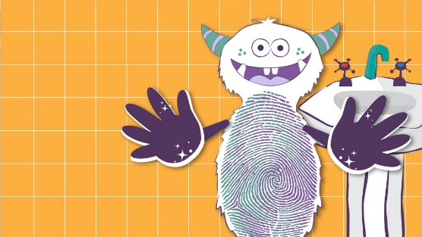

Rufus is a character that we will be introducing to your child in September. This character will help the children learn good practices on hand-washing.

We will be discussing this in conjunction with our Aistear/Siolta curriculum.

Any parent who has any queries feel free to email them and we will endeavour to respond as soon as possible

**Contact Details**

Tullacmongan Childcare Services

Tullacmongan Resource Centre

H12 W0V2

Telephone: 086 6690032/0494362283/0494372976

Email:[**tullacmonganrc@gmail.com**](mailto:tullacmonganrc@gmail.com)

Or on our Facebook page

**Policy on Authorisation to Drop Off and Collect Children**

**Updated to include information for COVID-19**

This policy outlines the protocols in relation to the collection of children from **Tullacmongan Childcare Service**. **Tullacmongan Childcare Service** shall only release children into the care of individuals who have been authorised by the parent(s)/guardian(s) to collect the child. This policy also includes the information and records required for each pre-school child, including children’s attendance. This policy is available and communicated to all parents.

This policy has been updated in line with current guidance the [HSPC Infection Prevention and Control guidance for services providing childcare during the COVID-19 Pandemic](https://first5.gov.ie/userfiles/files/download/8be9f2c0575d621e.pdf), the DCYA’s [Return to Work Safely Protocol](https://first5.gov.ie/userfiles/files/download/588eb944b2e5a65a.pdf) and [Tusla’s Children Services Regulations Guidance Document for Early Years Services: COVID-19](https://first5.gov.ie/userfiles/files/download/a07b466a23ee69c5.pdf)

**Principle**

This policy is underwritten by the he Child Care Act 1991 (Early Years Services) Regulations 2016 , The Child Care Act 1991 (Early Years Services) (Amendments) Regulations 2016. and Tusla’s Quality and Regulatory Framework.

**Policy:**

**Routine for drop-off and pick-up:**

Tullacmongan Childcare Service has established routines for drop-off and pick-up times to assist in transition of children into and out of the Service.

* On arrival at Tullacmongan Childcare Service parents and children are greeted at the door of their care room. Children are welcomed in to the room by Tullacmongan Childcare Service staff and their attendance is noted for our records.
* On departure, children are signed out by Tullacmongan Childcare Service staff. Sign out is done in line with our Authorisation to Collect policy below.

**Supervision when entering and leaving the service:**

During collection and drop off times, each child is under the direct supervision of a staff member. During collection time it is ensured that the child leaves the premises in the care of their parent/guardian or a person nominated by their parent/guardian. Staff record in the attendance book the time and their initials, when the child arrives in and leaves the service.

**Authorisation to collect a child:**

On enrolment at Tullacmongan Childcare Service, the following information is obtained for each child and retained in the service:

* The name and date of birth of the child.
* The date the child first attended the service.
* The name, address and telephone number of the person/s authorised by a parent or authorised nominee named in the child's record to collect the child from the premises.
* The relationship to the child of the persons authorised to collect the child from the premises.
* Details of any court ordered custody arrangements, or relevant legal evidence of individuals that are prohibited from collecting a child.
* The signature of the person providing authorisation.

All staff have a clear understanding of their roles and responsibilities in relation to accessing the Service and the authorisation process required prior to the collection of children from the Service.

**Procedure when non-authorised person arrives to collect a child:**

* In certain circumstances a parent may need to arrange a person other than those authorized in the application form to pick up their child. If the parent has to organise this arrangement with Tullacmongan Childcare Service over the phone and staff are not convinced of the authenticity of the caller’s identification, they will contact the parent under the contact number provided on the application form. The parent will be asked to sign a notification form taken by staff for this arrangement as soon as possible.
* To add another person to the list of people authorised for collection, the parent has to do so in writing.
* This is a key requirement for the protection and welfare of the child. If for any reason, Tullacmongan Childcare Service Staff feel the arrangement is not in the interest of the child’s welfare, the parent will be contacted, and the child will remain in the care of Tullacmongan Childcare Service until the situation is resolved.

**Late collections:**

* Where a parent knows they will be late collecting their child after the agreed time, they are required to consult with the service to make alternative arrangements.
* No fees are applied for late collections.
* If a child is not collected by a parent/ guardian by the agreed time, the service will contact the parent/ guardian or emergency contact persons.
* Regulations require two members of qualified staff to be present at all times when children are on premises.

**When a child is not collected:**

* If a child is not collected at the end working hours of Tullacmongan Childcare Service and the service is unable to contact the parents/guardians and emergency contacts, after 1 hour the following procedures apply:
* The child will stay at the service in the care of at least 2 fully vetted staff members until the premises close, or staff are no longer available for the child.
* Staff will follow procedures outlined in the Child Protection Policy. Contact An Garda Síochána and other relevant agencies.

**When person arrives to collect a child in an unfit state:**

* The service will not release a child who is deemed to be at risk, if a parent or authorised person arrives at the service and staff are concerned that they are in an unfit state due to drugs or alcohol.
* Staff will explain to the parent or the authorised person who is unfit, why the child should not leave with them and offer to assist them by contacting the other parent or authorised person for collecting the child.
* If the parent/ guardian refuses assistance and insists on taking the child with them although the staff believe the child will be at risk, the manager or staff in charge will call An Garda Siochána immediately.

**Tullacmongan Childcare Service shall ensure that a record in writing is retained for a period of 2 years from the date on which the child ceases to attend the service.**

**Procedure for authorisation of collections:**

* If a child is to be collected by a person other than their parent prior signed parental permission must be in place.
* The parent should provide the name, address, contact number of the persons authorised to collect their children and state the relationship of this person to the child.
* Authorised persons must be over 18* years of age (unless exceptional circumstances dictate)
* When an authorised person is to collect a child, the parent must inform the setting beforehand on each occasion. (in person or by phone)
* Only persons named and authorised by the parent may collect a child.
* The setting should be informed if one parent does not have guardianship and access to the child.
* The setting should be informed immediately of any changes to those authorised to collect their child.
* If the person authorised to collect the child is unknown to the service staff may ask the individual to produce photographic identification as prove of identity.
* The name of the parent or guardian providing authorisation. The signature of the person providing authorisation. The date the authorisation is signed.
* Our staff are able to seek emergency medical assistance for a child as required without seeking further authorisation from a parent or guardian (i.e. medical practitioner, ambulance or hospital) including for those emergencies relating to asthma and anaphylaxis.
* Where a non-authorised individual arrives to collect a child, and the parent(s)/guardian(s) are not contactable, the Service will contact the Authorised Nominee(s) listed in the child’s record.
* Where no authorised person arrives to collect a child, the Service attempts to contact the parent(s)/guardian(s) and each Authorised Nominee listed in the child’s record.

The service reserves the right to refuse entry to the service of any individual authorised or otherwise if it is determined that they pose a risk of harm to the safety, health and welfare of the service team and children. The service reserves the right to contact an alternative authorised contact on the child’s record to collect, if they determine the authorised contact that has arrived could pose a risk to the child.

**Procedure for Refusing Authorisation**

The procedure for authorising collections is that parents name two people on the child’s registration form when enrolling and then parents tell educators in advance each time an authorised person will be collecting the child. In the instance that authorisation from a parent/guardian does not meet the requirements outlined the team member will:

* Immediately explain to the parent/guardian that their authorisation cannot be accepted, explaining why. Educators will guide the parent/guardian on how to meet the requirements.
* Ensure that the parent/guardian is provided with a copy of the relevant service policy and that they understand the reasons for the refusal of the authorisation if so required.
* Request that an appropriate alternative authorisation is provided by the parent/guardian that complies with the requirements of the relevant service policy.
* Ensure that procedures outlined in the relevant service policy are followed where a parent/guardian cannot be immediately contacted to provide an alternative written authorisation
* Follow up with the parent/guardian, where required, to ensure that an appropriate written authorisation is obtained.
* It is the responsibility of the Service to ensure that all authorisations adhere to the requirements.

**Authorisation form:**Our child record form requires details for up to 2 persons authorised to collect a child (other than the parent) and also two nominated emergency contacts. Tullacmongan Childcare Service will ensure that the following information on at least two authorised individuals is kept on file for each child.

* First name and surname
* Address
* Home, Work and Mobile Phone Number
* Relationship to child

**Collections and Drop Offs During the COVID-19 Pandemic:**

Due to the ongoing COVID-19 Pandemic and in the interests of public health and on the advice of the Health Protection Surveillance Centre, the following procedure will be used by Tullacmongan Childcare Service until advised otherwise:

**Emergency Contacts**

* All parents/guardians will provide an additional emergency contact should an immediate collection be necessary should their child exhibit symptoms of COVID-19.

**Procedures for Drop Off**

* Parents/guardians and authorised collectors can no longer access Tullacmongan Childcare Service for drop off and collections.
* Staggered times may be arranged for all drop offs and parents/guardians may be designated a collection time when their child starts at Tullacmongan Childcare Service, we ask that in the interests of social distancing all parents/guardians be mindful of their designated time.
* **Where parents/guardians travel with their child by public transport, or by active travel, they will be asked to meet a staff member for drop off at the designated area, which is marked out as a hopscotch to the front of the building. All adults are asked to please respect social distancing markers and instructions.**
* Where parents/guardians drop off their children by private car, they will be asked to remain in their car at [designated area] and their child will be collected from the car by a designated staff member of Tullacmongan Childcare Service.
* We ask all parents/guardians to limit their interactions with staff and other parent/guardians.
* All parents/guardians should follow public health advice and follow social distancing advice and give all other waiting parent/guardians the recommended 2m distance.

**Procedures for Collection**

* As with Drop Offs, parents/guardians can no longer access Tullacmongan Childcare Service for collections.
* Staggered times are in place for collections and parents/guardians are designated a collection time when their child starts at Tullacmongan Childcare Service, we ask that in the interests of social distancing all parents/guardians be mindful of their designated time.
* Where parents/guardians travel with their child by public transport, or by active travel, they will be asked to wait to collect their child at [designated area], which is clearly marked. All adults are asked to please respect social distancing markers and instructions.
* Where parents/guardians collect their children by private car, they will be asked to remain in their car and wait for a designated staff member to meet them with their child.
* We ask all parents/guardians to limit their interactions with staff and other parent/guardians.
* All parents/guardians should follow public health advice and follow social distancing advice and give all other waiting parent/guardians the recommended 2m distance.

**Collections for Children Exhibiting Symptoms of COVID-19**

* Should a child at Tullacmongan Childcare Service exhibit symptoms of COVID-19, their parents/guardians will be called and be asked to collect them immediately.
* If a parent/guardian cannot be reached at their provided phone numbers their emergency contacts will be called and asked to collect the child.
* Where parents/guardians travel with their child by public transport, or by active travel, they will be asked to wait to collect their child at [designated area], which is clearly marked. All adults are asked to please respect social distancing markers and instructions.
* Where parents/guardians collect their children by private car, they will be asked to remain in their car and wait for a designated staff member to meet them with their child.

**Infection Control Policy**

**Policy Statement**

It is the priority of Tullacmongan Childcare Service to protect all children attending our service and all persons working in our service from the transmission of infections. The health and well-being of all children, staff and visitors to our service is paramount and our aim is to prevent and manage any infection which may be present in the service. This policy is available and communicated to all parents, children and staff. . This policy has been updated in line with current guidance the [HSPC Infection Prevention and Control guidance for services providing childcare during the COVID-19 Pandemic](https://first5.gov.ie/userfiles/files/download/8be9f2c0575d621e.pdf), the DCYA’s [Return to Work Safely Protocol](https://first5.gov.ie/userfiles/files/download/588eb944b2e5a65a.pdf) and [Tusla’s Children Services Regulations Guidance Document for Early Years Services: COVID-19](https://first5.gov.ie/userfiles/files/download/a07b466a23ee69c5.pdf)

Principle

This policy is underwritten by the he Child Care Act 1991 (Early Years Services) Regulations 2016 and the Child Care Regulations (The Child Care Act 1991 (Early Years Services)( Amendments) Regulations 2016. and the Tusla Quality and Regulatory Framework

**Rationale**

Infection can lead to serious ill-health among children. Infection control procedures seek to reduce the risk of children getting sick in a service by ensuring good hygiene is followed and the risk of infection is minimised. This will be communicated with parents, so good hygiene and infection control practices will be carried over from the service to home and vice versa.

**Risk Assessments**

* Risk assessments will always be undertaken by staff to assess if activities, actions or environments posts risks from an infection control standpoint to the children and staff of Tullacmongan Childcare Service.

**Hand washing**

* Tullacmongan Childcare Service has a hand washing policy which all staff promote and model for children, after using the toilet, before eating/preparing food, after wiping noses, waste disposal and mopping up spills.
* Staff must wash their hands, before preparing or serving food, before eating or drinking, after going to the toilet, assisting children going to the toilet, dealing with bodily fluids, cleaning procedures, caring for sick children, handling soiled clothing, dealing with waste and after removing disposable gloves.
* A wash hand basin is provided in each room with a constant supply of hot (no greater than 43c) and cold running water, liquid anti-bacterial soap and paper towels. A wash hand basin is also available in all bathrooms, kitchens and activity rooms.
* Children are encouraged to wash their hands with warm water and liquid soap under supervision after visiting the toilet, before eating, after sneezing, coughing or blowing noses, after handling animals, after touching a cut or sore and after outside play and activities. Clear guidance on handwashing is outlined for children and staff alike in our service.
* Staff will supervise and assist children to encourage effective handwashing, appropriate to their age.

**Food preparation**

* Staff always wear gloves when preparing and serving food and wash hands after removing gloves.
* Staff always wash their hands after prepping food and removing waste food and materials.
* Perishable food is kept in a refrigerator, between temperatures of 0 and 5 Celsius. Any perishable food left at room temperature for more than 2 hours will be discarded safely.
* Staff involved in helping children with toileting are not involved in preparing food.

**Cleaning and the premises**

* All staff are aware of their role in maintaining high standards of hygiene.
* Tullacmongan Childcare Service reinforces good practice regarding keeping the environment and premises clean and safe.
* Spillages of blood, faeces, urine, vomit or other bodily fluids or excretions are cleaned immediately and with priority. Disposable tissue paper and mops are not be used for these and extreme caution is exercised at all times.
* Daily, weekly and monthly cleaning schedules are in place and records kept.
* Tullacmongan Childcare Service has a contract with a bin removal company for the removal and disposal of all waste at Tullacmongan Childcare Service.
* Our premises are free from pests and rodents and we have a contract with an external agent who checks our premises on a monthly basis.
* All staff receive regular support & supervision in relation to infection control and training is provided.
* We carry and maintain a good stock of cleaning products and tools to ensure that hygiene practices can be carried out at all times. Adequate supplies for cleaning are provided to be used, like clean cloths, gloves, aprons, mops, buckets and detergents.
* Toys and play materials are cleaned daily, with attention placed on especially soiled items. They are not brought into the toilet. Toys are chosen that are easy to clean and disinfect.
* Toys are not shared.
* Personal soft toys and items like blankets are not shared.
* Toilets, floors, shelves storing bags, tables and chairs and other areas are cleaned daily to help decrease the spread of infection, cleaning agents used are detailed on our cleaning schedules.
* Children have individual hairbrushes, toothbrushes, dental products, clothing and towels. These items are not be shared. Any soiled clothes are placed in a plastic bag, sealed and sent home with parents/guardians.
* At least once a day, even in winter, all rooms in the service are aired out.
* Master cleaning schedule located in the office and cleaning schedule for each room is on the walls in each care room.

**Nappy Changing and Toileting**

* The nappy changing room and toilets are adequately ventilated, by window/mechanical ventilation.
* A wash basin is included in the nappy changing room and has hot and cold running water and access to liquid soap and paper towels. Staff must wash and dry their hands before and after nappy changing.
* Children’s hands will be washed and dried after nappy changing, staff will also ensure that they have thoroughly washed their own hands before and after nappy changing.
* Staff that are changing nappies use disposable gloves that are removed before re-dressing the child.
* All nappy changing mats used are waterproof, in good condition i.e. no exposed stuffing or foam and have an easily cleanable cover. Nappy changing mats are wiped down by staff after each nappy change.
* Children are never left unattended while having their nappy changed.
* All nappies are disposed of in a way which will not risk infection. Soiled nappies are stored in an airtight, sealed container that is removed from the premises at least once per day. Nappy disposal containers are kept away from children and out of their reach. Nappy changing units are cleaned thoroughly on a regular basis.
* All staff are be fully trained and briefed in nappy changing and infection control.
* Nappy changing should be a pleasant experience for the child and staff members should use this opportunity to interact with the child and provide one to one attention.

**Immunisation**

* Our immunisation policy is followed at all times with all children and staff.
* Children’s immunisation records are obtained when children begin in Tullacmongan Childcare Service. Parents are asked to update Tullacmongan Childcare Service when children receive additional immunisations.
* Parents have a right to choose to whether to immunise their child or not.
* If a child is not immunised, for their own safety they may be excluded from Tullacmongan Childcare Service if an infectious disease that they are not immunised against is circulating. Parents will always be consulted on this. We always work in the best interests of children’s health.
* We provide information leaflets on immunisation schedules, oral hygiene and prevention of infection to parents.

**Animals and pets**

* Handwashing and drying procedures is followed before and after handling any animals and pets that are present in Tullacmongan Childcare Service.
* All animals and pets are managed in accordance with required and appropriate instructions for their care.
* Children are supervised with animals at all times.
* All our animals are regularly checked with vets.

**Procedure for Managing an infectious illness**

* Children are encouraged to cover their nose and mouth with a tissue before sneezing or coughing. Hands are washed after blowing noses, sneezing or coughing.
* Staff will report any illness to the manager/designated person in charge.
* Unwell children, with a temperature and/or specific signs and symptoms, will be excluded from the service until a diagnosis can be made. Staff can and will use their discretion when admitting a child back into Tullacmongan Childcare Service, if they believe the child is still ill and cannot take part in their usual activities.
* Any child is displaying symptoms such as a cough, fever or breathing difficulties should not attend the service (COVID-19)
* Parents are advised to contact the service as soon as possible if their child is unwell and unable to attend.
* Children should remain at home if they are suffering from general diarrhoea or vomiting for at least 48 hours.
* A plan will be drawn up to help prevent the spread of the illness and the [*HSE guidelines: Managing an infectious disease in childcare setting*](https://www.hpsc.ie/A-Z/LifeStages/SchoolHealth/File,13445,en.pdf)will be followed.
* Communication will issue to parents if there is an infectious disease circulating in Tullacmongan Childcare Service.
* Notifications will be placed on our noticeboard should any outbreaks be ongoing in Tullacmongan Childcare Service.

**Exclusion table:**

The following exlcuison periods are followed in Tullacmongan Childcare Service. In certain instances, the exclusion period may be longer than outlined below:

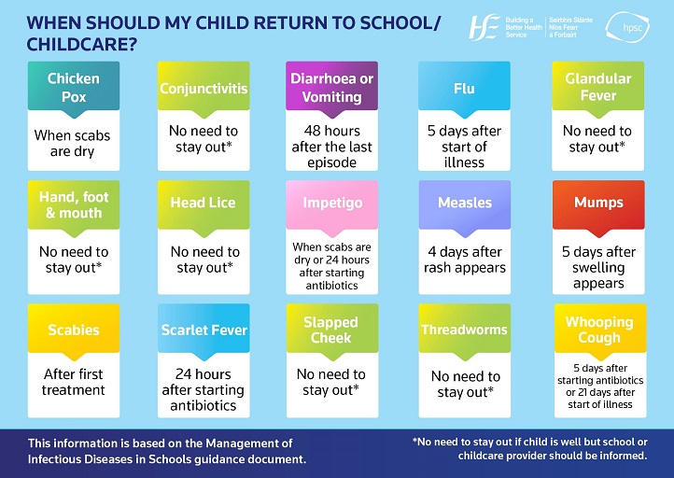

**Notifiable disease:**

* A list of notifiable diseases is available from the [HSE](https://www.hpsc.ie/NotifiableDiseases/). In the case of notified diseases or if the illness spreads the manager will notify the Tusla Early Years Inspectorate by filling out the [Notification of Incidents Form](https://www.tusla.ie/services/preschool-services/notification-of-incidents-form/) and the HSE Public Health Department.
* When we have been contacted by the Department of Public Health, HSE, in our area and have been advised that we have a confirmed case as listed we will contact Tusla, Early Years Inspectorate. The Department of Public Health Medicine will advise as to the next steps regarding precautions to be taken in oour premises and follow up of contacts and procedures.
* Parents will be informed verbally and in writing if an outbreak has occurred – all reasonable information on the outbreak will be provided to them.

**COVID-19 Infection Control Guidelines in Tullacmongan Childcare Service**

* To prevent the spread of COVID-19 in Tullacmongan Childcare Service, Tullacmongan Childcare Service implements a “play pod” system.
* Play pods are organised across [x] rooms in Tullacmongan Childcare Service, A record of play pods and their makeup is recorded and will be shared with the HSE and Public Health teams in the event of an outbreak of COVID-19.
* Pods, as much as practical, do not mix, share toys, play materials or equipment. Each pod also has different break and meal times. Outdoor time is separate for each play pod.
* We follow the 2m physical distancing recommendation by the National Public Health Emergency Team for adults
* Tullacmongan Childcare Service has [x] number of hand washing stations, and [x] number of hand sanitiser stations – all staff are encouraged to use and to follow our handwashing policy above.
* The National Public Health Emergency Team recommends the use of cloth face coverings in certain indoor settings, however it is not mandatory in Tullacmongan Childcare Service. We have masks available as needed.
* Tullacmongan Childcare Service’s master cleaning schedule can be seen in the appendices of this policy [attach your cleaning schedule].

**Dealing with Suspected COVID-19 Cases in Tullacmongan Childcare Service**

If a child or staff member in Tullacmongan Childcare Service feels unwell and develops symptoms:

* If a child develops any symptoms of acute respiratory infection including cough, fever, or shortness of breath while in Tullacmongan Childcare Service, a staff member will take the child to [area marked for isolation]. This should be a room if possible but if that is not possible it should be in a place 2m away from others in the room.
  + Parent/guardians will be called and asked to collect their child as soon as possible.
  + A staff member will remain with the child at all times until parent/guardian arrives. Due to the nature of COVID-19 physical distance will be need to be retained as much as possible, and the staff member will need to wear a facemask and gloves.
* If a staff member develops symptoms of acute respiratory infection including cough, fever or shortness of breath while in the care facility ask them to go home without delay and contact their GP by telephone.
* They will be located 2 m away from others as much as possible.
  + They will be asked to avoid touching people, surfaces and objects and be advised to cover their mouth and nose with a disposable tissue when they cough or sneeze and put the tissue in the bin. .
  + They will be asked to wear a mask.
* If there is an emergency, staff will call an ambulance, and explain that the child or staff member is unwell with symptoms of COVID-19.
* Any rooms where children or staff need to be isolated is cleaned and contact surfaces disinfected once they leave.

**What we do when there is a confirmed case of COVID-19 in Tullacmongan Childcare Service**

* We advise all individuals with symptoms of COVID-19 to contact their GP for further advice.
* Tullacmongan Childcare Service will liaise with local Public Health staff of the HSE to discuss the case, identify people who have been in contact with them and advise on any actions or precautions that should be taken.
* Tullacmongan Childcare Service will notify Tusla Early Years Inspectorate of any confirmed case of COVID-19 in the service.
* An assessment of each childcare setting where this may occur will be undertaken by HSE public health staff.
* Advice on the management of children and staff who came into contact with the case will based on this assessment.
* The HSE Public Health staff will also be in contact individually with anyone who has been in contact with the case to provide them with appropriate advice.
* Cleaning of Tullacmongan Childcare Service will commence following HPSC advice and guidance.
* Symptomatic are advised to self-isolate and arrange to get tested for COVID-19.
* We will advise confirmed COVID-19 cases to continue to self-isolate at home for a minimum of 14 days and not return to Tullacmongan Childcare Service until they are advised that it is safe to do so.

**Close contacts of a confirmed case will be advised to go home and restrict their movements for 14 days. Tullacmongan Childcare Service will ask them to not come to Tullacmongan Childcare Service for 14 days**